PRESS RELEASE from the Office of Dr. Elba Pacheco, Oculofacial Plastic Surgeon and Rejuvenation Artist …
Kybella™ has arrived at Adoro Medical Spa!
Adoro Medical Spa is excited to bring you Kybella™, the new FDA approved injectable treatment that reduces fat under the chin permanently.
The double chin is a common issue plaguing men and women alike. In the past surgery was the only option – UNTIL today! Kybella™ destroys fat cells under the chin giving you a more contoured appearance. Come for a quick consultation and we will determine whether you are a Kybella™ candidate.
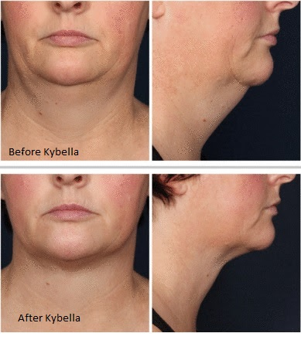

Kybella™ benefits:
- Substantial reduction of excess fat under the chin
- No surgery
- No significant downtime
- Performed in the physician’s office (30 min appointment)
- Permanent results – some patients will require 2 – 4 treatments to achieve optimal results
For many years, Dr. Pacheco and her office has been recognized for being the best injector of dermal fillers and the best Medi-Spa in the Annapolis region. Come experience the quality, commitment and cutting-edge care that is unsurpassed. Call Today - 410-647-0123 and get started ‘Opening Your Eyes to the Possibilities’! www.myeyelids.com
10/09/2015

